**Iteration 2 Report**

**Customer Meeting**

We did not meet the customer in this iteration.

**Meeting Video**

None

**User Stories**

* As an administrator, I would like to sign up for the management system, so that I could use the system.
* As an administrator, I would like to see the drivers’ and passengers’ position on the map, so that I could know where they are.
* As an administrator, I would like to log in to the management system, so that I could use the system.
* As an administrator, I would like to reset the password, so that I could use the system even if I forget the password.
* As an administrator, I would like to add drivers to the database, so that I could know who the drivers are.
* As an administrator, I would like to edit drivers’ information, so that I could keep their information updated.
* As an administrator, I would like to delete drivers from the database, so that I could see if any driver quits.
* As an administrator, I would like to add other administrators to the database, so that I could know who the administrators are.
* As an administrator, I would like to edit administrators’ information, so that I could keep their information updated.
* As an administrator, I would like to delete other administrators from the database, so that I could see if any administrator quits.
* As a TAMUber manager, I'd like to manage driver information, so that I can have clear information of driver's.

**Design Diagram**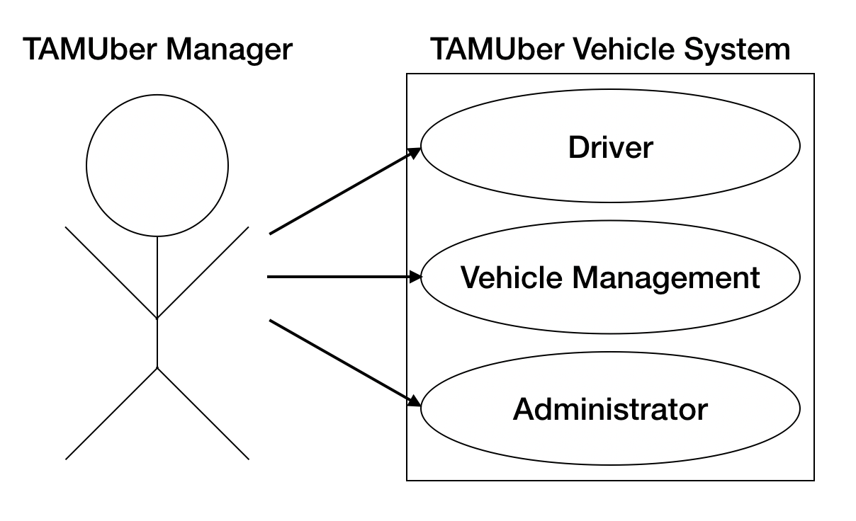

**Evaluations of Code and Tests**

rspec:

* rspec ./spec/controllers/driver_spec.rb

DEPRECATION WARNING: [Devise] including `Devise::TestHelpers` is deprecated and will be removed from Devise.

For controller tests, please include `Devise::Test::ControllerHelpers` instead.

(called from <top (required)> at /Users/yangchuya/Documents/tamu/software_engineering/TAMUber/spec/controllers/driver_spec.rb:3)

............

Finished in 0.14638 seconds (files took 4.73 seconds to load)

12 examples, 0 failures

Coverage report generated for RSpec to /Users/yangchuya/Documents/tamu/software_engineering/TAMUber/coverage. 37 / 104 LOC (35.58%) covered.

* rspec ./spec/controllers/user_spec.rb

DEPRECATION WARNING: [Devise] including `Devise::TestHelpers` is deprecated and will be removed from Devise.

For controller tests, please include `Devise::Test::ControllerHelpers` instead.

(called from <top (required)> at /Users/yangchuya/Documents/tamu/software_engineering/TAMUber/spec/controllers/user_spec.rb:3)

.

Finished in 0.02884 seconds (files took 1.51 seconds to load)

1 example, 0 failures

Coverage report generated for RSpec to /Users/yangchuya/Documents/tamu/software_engineering/TAMUber/coverage. 15 / 113 LOC (13.27%) covered.

* rspec ./spec/controllers/vehicles_controller_spec.rb

DEPRECATION WARNING: [Devise] including `Devise::TestHelpers` is deprecated and will be removed from Devise.

For controller tests, please include `Devise::Test::ControllerHelpers` instead.

(called from <top (required)> at /Users/yangchuya/Documents/tamu/software_engineering/TAMUber/spec/controllers/vehicles_controller_spec.rb:4)

...........

Deprecation Warnings:

Using `should` from rspec-expectations' old `:should` syntax without explicitly enabling the syntax is deprecated. Use the new `:expect` syntax or explicitly enable `:should` with `config.expect_with(:rspec) { |c| c.syntax = :should }` instead. Called from /Users/yangchuya/Documents/tamu/software_engineering/TAMUber/spec/controllers/vehicles_controller_spec.rb:80:in `block (4 levels) in <top (required)>'.

If you need more of the backtrace for any of these deprecations to

identify where to make the necessary changes, you can configure

`config.raise_errors_for_deprecations!`, and it will turn the

deprecation warnings into errors, giving you the full backtrace.

1 deprecation warning total

Finished in 0.14004 seconds (files took 1.53 seconds to load)

11 examples, 0 failures

Coverage report generated for RSpec to /Users/yangchuya/Documents/tamu/software_engineering/TAMUber/coverage. 36 / 104 LOC (34.62%) covered.

**Pivotal Tracker**

<https://www.pivotaltracker.com/n/projects/2205674>

**Github Repo**

<https://github.com/ShaoEnChen/TAMUber>

**Heroku**

<https://tamu-uber.herokuapp.com/>